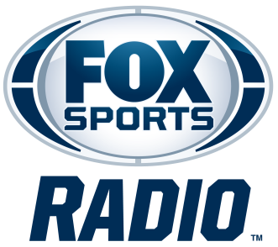

LAVAR ARRINGON
BIOGRAPHY

LaVar Arrington is co-host of FOX Sports Radio's weekday morning program, 2 Pros and a Cup of Joe, alongside Brady Quinn and Jonas Knox. Airing Monday through Friday from 6–9 a.m. ET on more than 400 stations nationwide and streaming on iHeartRadio, the show features the trio's entertaining and thought-provoking conversations on the biggest stories in sports and beyond.
Arrington is also co-host of FOX Sports Radio's national weekend show and podcast, Up On Game, alongside T.J. Houshmandzadeh and Plaxico Burress. Airing Saturdays from 12–2 p.m. ET on more than 400 radio stations nationwide and streaming live on iHeartRadio, the program tackles the latest sports headlines through the unique perspective of former professional athletes. Drawing on their extensive playing experience, the hosts educate, inspire, and entertain listeners through candid conversations, personal stories, and insightful discussions designed to help athletes and fans better understand the game on and off the field.
In December 2021, Arrington partnered with FOX Sports Radio to launch the Up On Game Presents podcast network, featuring a diverse lineup of sports and culture-focused programs hosted by distinctive personalities.
Arrington previously co-hosted FOX Sports Radio's nationally syndicated FOX Sports Sunday alongside Mike Harmon. He joined the network as a weekend host in February 2020 after several years hosting radio in Washington, D.C., where he also produced a multimedia blog for The Washington Post. In addition to his radio responsibilities, Arrington is a regular contributor on FS1.
One of the most decorated defensive players in Penn State history, Arrington earned All-Big Ten honors and was a two-time All-American, including consensus All-American recognition in 1999. That season, he captured the Dick Butkus Award and Lambert Award as the nation's top linebacker, as well as the Chuck Bednarik Award as the nation's top defensive player. In 2022, he was inducted into the College Football Hall of Fame.
Beyond broadcasting and football, Arrington remains active in athlete development and education. Through his media company, DisruptU PSU, he partnered with the Penn State Brand Academy and iHeartMedia to help connect Penn State student-athletes with national NIL (Name, Image and Likeness) opportunities.
Arrington was selected with the No. 2 overall pick in the 2000 NFL Draft. A three-time Pro Bowl linebacker, he played six seasons with Washington before joining the New York Giants and retiring following the 2006 season.
Fans can follow @LaVarArrington on X and @King_of_the_Mammals on Instagram.

